HARVEST for Windows

Timber Harvest Simulation Model

Version 6.1

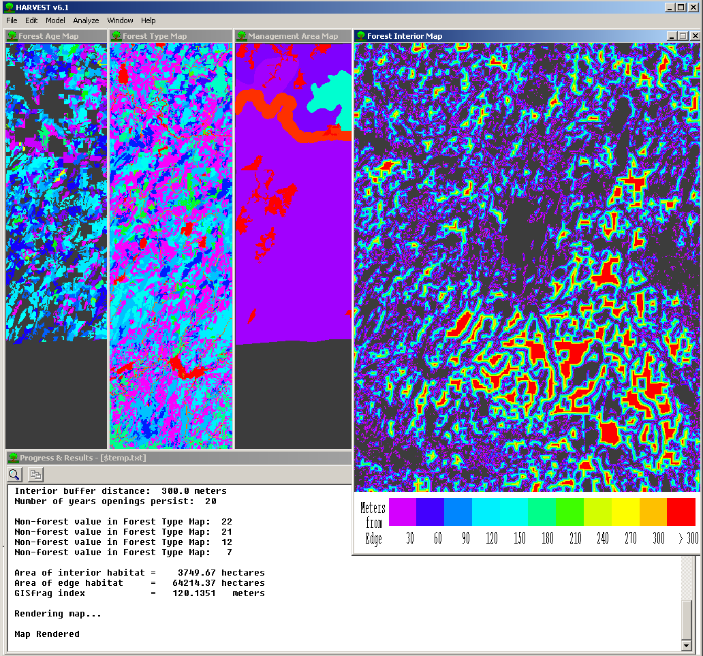

User’s Guide
Written by:

Eric J. Gustafson

Luke V. Rasmussen
North Central Research Station
5985 Highway K

Rhinelander, WI 54501


Table of Contents
Description 3
Installing Harvest 6.1 4
Preparing input files 4
Simulating harvests using Harvest 6.1 7
FILE 7
Load map set 7
Save 7
Clear log file 8
Exit 8
EDIT 8
Preferences 8
Map header 9
MODEL 9
Execute 9
Program Harvest Script 15
Execute Harvest Script 15
Useful details about how the simulation model works 16
Using the analysis features of Harvest 6.1 17
ANALYZE 17
Patches 17
Interior 18
Complete 19
Query Stand 19
WINDOW 19
HELP 19
Script file format 20
Common problems and how to fix them 21
Using HARVEST for research or strategic planning 21
References 23
Citation information 24

HARVEST for Windows
Timber Harvest Simulation Model

Version 6.1

User’s Guide

Guide revised: September 27, 2005

Description

HARVEST was designed as a strategic research and planning tool, allowing assessment of the spatial pattern consequences of broad timber management strategies. The model is well suited to evaluate alternative strategies by providing comparable predictions about how the alternatives affect the age (or successional stage) distribution of the forest, the spatial distribution of forest interior and edge habitats, and the patch structure of the resulting forest landscape. With HARVEST, the object is not to find a scheduling solution (i.e., determining the order in which individual stands should be harvested), but to assess the spatial pattern consequences of general management strategies. HARVEST has been shown to generate patterns similar to those produced by timber management (Gustafson and Crow 1999).

HARVEST may also be used to visually portray non-spatial outputs from harvest scheduling models such as SPECTRUM. Additionally, the spatial feasibility of the model solution can be evaluated when harvest activities are subject to constraints (such as adjacency) that are not addressed in the scheduling model.

The stochastic nature of HARVEST allows the user to replicate a management strategy many times to determine average spatial metrics with confidence intervals. The model also facilitates ‘what-if’ experimentation to explore the spatial effects alternative management options.

HARVEST simulates harvest practices that reset the age of forested sites to a specific age. This includes even-aged timber harvest techniques (e.g., clearcutting, shelterwood, seed tree techniques) and uneven-aged group selection. Version 6.1 has some capability to simulate other uneven-aged techniques where such treatments predictably change stand structure, by using stand age as a surrogate for stand structure.

HARVEST allows the user to interactively simulate harvest activities that are targeted to forest type and management area (MA). Management areas are relatively large, multi-stand areas that are to be managed by specific objectives. The user specifies harvest parameters (such as harvest size, rotation age, green-up interval), for a management area and forest type. The process may be repeated for multiple management area/forest type combinations and time steps.

HARVEST 6.1 is similar to v6.0, but has several significant changes. Version 6.1 allows the user to specify any combination of two treatment effects when a harvest is implemented: 1) the age to which the treated cells are set and 2) whether the forest type will be converted upon cutting (e.g., planting). This is useful to simulate planting (or under-planting), or other silvicultural techniques that convert forest type and/or reset stand age. These combined effects can be used to simulate simple, deterministic succession or disturbances by converting the forest type of cells that are above a specified age without resetting the age. HARVEST 6.1 also can display the forest type and the management area maps at any time, and to save the forest type map (v6.0 had a fixed forest type map; v6.1 allows conversion and succession.) The menus of version 6.1 have also been re-designed.

HARVEST can conduct several analyses of the spatial pattern of the landscape both before and after simulated harvest. The patch structure (patches defined by stand age or forest type) can be analyzed for the entire mapped area or by individual management areas. The amount of forest interior and edge habitat can be calculated and displayed according to the definition of interior given by the user. Version 6.1 adds calculation of the fragmentation index GISfrag (Ripple et al. 1991). Analysis results of simulations can be saved spatially as GIS maps and in tabular form as a text file. An option to submit internal and saved maps to the landscape pattern analysis program APACK (Mladenoff and DeZonia 2004) is now provided.

HARVEST was written by Eric Gustafson and Luke Rasmussen in Fortran 95 using the Winteracter Windows libraries. Address comments and questions to:

Eric Gustafson
USDA Forest Service
North Central Research Station
5985 Highway K
Rhinelander, WI 54501-9128
egustafson@fs.fed.us

The most recent version of HARVEST and its documentation may be obtained from the North Central Research Station Web site: http://www.ncrs.fs.fed.us/4153/harvest/v61/default.asp.

This guide has been formatted for double-sided printing and insertion into a loose-leaf binder.

Installing Harvest 6.1
Download and save the self-extracting file Harv61.exe to your hard drive. Save it in a new directory, or one in which you wish to use Harvest.
Uncompress the file by double-clicking on the file.
The following files should be found following this operation:
Harvest61.exe The Harvest program
Viewer.exe A utility program used to view Erdas 7.4+ GIS map files
Help61.txt Online help file
Harv61 User.doc The file you are now reading
Rgb.dat Color table for the Harvest program
Rgb192.dat Color table for the Viewer program
Sample.hsc Example of a script file

To run Harvest, open the file Harvest61.exe.

Preparing input files
Harvest operates on a grid-cell (raster) representation of the landscape. Harvest requires a set of 4 input map files to simulate harvest activity: forest age map, forest type map, management area map, and a stand identification number (ID) map. These maps are typically prepared using a GIS, and exported for use by Harvest. Each input map file in the set must be of the same area, and have the same (square) cell size and number of rows and columns. These files must be in an Erdas v7.4+, 8- or 16-bit GIS file format, typically with a .gis extension. Many common GIS programs can export this format. 4-bit files will not be created if the highest cell value in the output GIS file is >16. To create an Erdas v7.4+ format file from an Arc grid (ESRI Arc/Info), use the GRIDIMAGE command at the arc: prompt (not the grid: prompt). In ArcGIS, use the Grid To Image command located in Arc Toolbox.
Forest Age Map file: This map contains cells whose values represent the age (in years) of the forest on each cell. This map is used by Harvest to determine if cells meet the age constraints for harvest. This map is typically prepared from a GIS stand map, assigning values based on the age attribute, or calculated from the year of origin of the stand. Cells with a value of zero are assumed to be areas that will never be harvested (land owned by others, inoperable, permanently reserved from harvest, etc.), or are non-forested areas such as streams, roads and agricultural areas. Assigning zeros here is one way to exclude parts of the mapped area from harvest. Another is to designate management areas (see below) in which you never specify any harvest activity. As you generate the forest age map, stands (forested cells) that have an actual age of zero (recently cut) should be assigned an age of 1. Negative numbers are not supported in the Erdas file format, and should not be used. Age values up to 32,767 are supported.
Forest Type Map file: Each cell in this map contains a user-assigned integer code value (between 1 and 32,767) denoting a specific forest type. Cells with a value of zero are ignored by HARVEST. This map is used by Harvest to apply harvest rules to the correct forest type. HARVEST also uses this map when leaving uncut buffers (typically riparian buffers), and to identify the non-forest land when calculating the amount of forest interior and edge habitats. HARVEST does not attach labels to the map values, so users must document the values representing each forest or land cover type. This map is typically produced in a multi-stage process. First, the forest types are gridded from the forest type attribute in a GIS stand map. You may wish to aggregate types to match the types relevant to silvicultural treatments to reduce the number of harvest specifications you must make when simulating with HARVEST. For example, you may wish to aggregate aspen and birch species into a single type. Secondly, you may want to overlay the land cover types that you will wish to leave uncut buffers around (e.g., streams, lakes, and maybe even roads.) If you do this, be sure to also conduct a similar operation on the age map to ensure that these cells have a zero age value, or these cells will age during the simulations as if they were uncut forest. Optionally, you may want to mosaic this map with land cover information for the parts of the age map that are coded with zeros (e.g., outside your ownership). This may be information derived from a satellite image classification (e.g., USGS GAP program) or other land cover data (e.g., USGS LUDA data.) The minimum information required for the parts of the map where there are zeros in the age map is 2 classes: forest and non-forest. Providing this information will allow you to generate forest interior/edge maps for the entire image, rather than just where there are non-zeros in the age map. It is important to include at least one cell of each potential forest type value (e.g., late successional species) in the starting map. Forest types that are not present in the initial map will not be recognized by HARVEST in subsequent time steps.
Management Area Map file: Each cell in this map contains a user-assigned integer code value (between 1 and 32,767) denoting the management area in which that cell falls. Cells with a value of zero are ignored by HARVEST. A management area is a multiple-stand area in which all the stands will be treated with similar, specific management practices. Management areas with the same value need not be contiguous. This map is used by Harvest to apply the harvest strategies you specify to the correct management area. If you do not wish to distinguish separate management areas, then produce a management area map with a single value for all cells. This map of MAs remains constant throughout a simulation of multiple time periods.
Stand ID map file: This is a map of stand ID numbers, where each stand ID value is a unique integer <64,535. This map is used by Harvest to track harvest activity in stands. It is often produced from the stand age map by passing the age map through a GIS clumping algorithm (e.g., REGIONGROUP in Arc GRID, CLUSTER in EPPL). HARVEST reads the maximum stand ID value (n) from the file header, and assumes that stand ID values start at 1, and that there are no missing integers between 1 and n. Cells with the same ID value will usually be contiguous (stands that are not fragmented into noncontiguous parts), but this is no longer required in v. 6.1. This map of stand IDs remains constant throughout a simulation of multiple time periods.
Figure 1 shows examples of each of these maps for a hypothetical landscape.

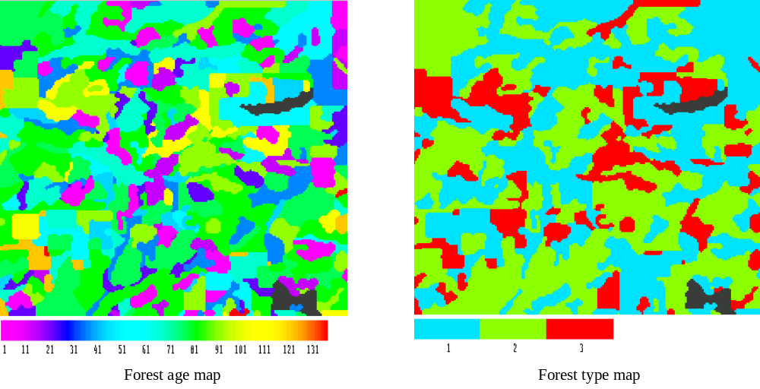
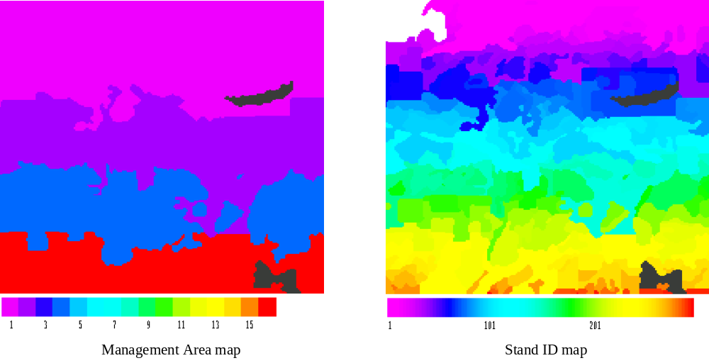
Figure 1. Hypothetical examples of the four input maps required by HARVEST. The color bars show the values associated with the colors for each map, and black represents values of zero. The management area map contains values of 1, 2, 4 and 16. The Stand ID map has 292 stands, and many adjacent stands are difficult to distinguish with only 255 colors.

Tips for preparing input maps
- The stand ID map can be made by intersecting forest type, age, and MA maps. It is not important to control specific stand ID values, as long as values do not exceed 64,535.
- Try to avoid “slivers” by combining small areas of unique forest types/ages/MAs with similar larger adjacent polygons. This will increase simulation efficiency without compromising important detail, especially in larger landscapes.
- When using the ‘stand filling’ option for harvest routines, you may want to pass the stand ID map through a stand-splitting algorithm to break apart stands larger than a user-defined threshold. For example, if you plan to use the stand filling option but don’t want harvests larger than 40 acres, it may make sense to split apart stands that are larger than 40 acres.

Simulating harvests using Harvest 6.1
HARVEST provides guidance for new users through context-sensitive “helper dialogs.” To turn this feature on, select ‘Preferences’ under the Edit menu item. Check the “Show helper dialogs” checkbox. After you become familiar with the operation of HARVEST, you may turn this feature off by clearing this checkbox (click on the checkbox to clear it).

FILE

This menu item allows you to load and save the files used by HARVEST.

Load map set

This command allows you to select the 4 map files on which HARVEST operates. A standard Windows File Selection dialog box will open, allowing you to choose the files you wish to use. The input files must be in ERDAS v. 7.4+, 8- or 16-bit format, and will typically have a .gis extension. The first map requested is the forest age map. HARVEST will report when maps have completed loading. If some of the map information needed by HARVEST is not present in the map header (e.g., cell width or unit of area), or if the map’s units are different from the default units that you have defined (explained more under the Preferences menu item), HARVEST will prompt you to supply this information. (See section EDIT- Map header below for further explanation of map units and cell size units.) After you select the age map, it will be displayed on the screen. You will then be prompted for a forest type map. If some of the map information needed by HARVEST (for this and subsequent map files) is not present in the map header, HARVEST will offer to use the information from the age map. You will notice a check box that will cause HARVEST to update this missing information in these maps so you will not have to do it each time you load these maps. You will next be prompted for a management area map. Lastly you will be prompted for a stand ID map.

Maps other than the stand age map are not displayed initially. Use the options under the Window menu to view these maps.

If you wish to use Harvest to calculate patch or interior metrics only, loading the MA and stand ID maps is optional (press Cancel when prompted for those maps). If you do not load the management area map, you will not be able to calculate patch metrics by management area.

In addition to a map window, a text window will also appear. This window will allow HARVEST to communicate results and progress to you. All of the information appearing in this window is also recorded in a log file that you may save for future reference (see Save menu item below).

Save

This menu item allows you to save the results of your simulations and analyses.

Age map

You may save the simulated age map at any time. The map will be saved in an ERDAS 7.4 format, which can be used as input to other HARVEST runs, or loaded into many common GIS systems. Note that once you load a new map set, all previous maps are cleared from memory, so remember to save maps prior to loading another map set.

Forest Type map

You may save the current forest type map at any time. This map is also saved in an ERDAS 7.4 format.

Interior map

You may also save the current interior map at any time. This map is also saved in an ERDAS 7.4 format. The map you see on the screen is the map that will be saved. Once you conduct a new analysis of interior (or load a new map set), any prior interior maps are cleared from memory and cannot be retrieved later.

Log file

A running log of your HARVEST session is maintained by HARVEST and displayed in the Progress and Results window. This log records the input files and the parameters you used, and the results of any analyses you conducted. If you conduct multiple analyses (including the use of many different interior calculation parameters, these will all be appended to this running log. The running log is cleared when you load (or re-load) a map set. You may save this log at any time, although it is cleared by saving, and when a new map set is loaded.

Clear log file

This option will clear the contents of the Progress and Results window. You will be given the option to save the contents of this window before it is cleared.

Exit

This option will close the HARVEST program. You will be reminded to save files, should you desire to do so.

EDIT

The Edit menu item allows you to edit certain files.

Preferences

You may set the defaults that appear in several of HARVEST’s dialog boxes. You also can turn the Helper dialogs on or off. The Helper dialogs provide context-sensitive instructions to new users. As you become experienced using HARVEST, they will become unnecessary, and may be turned off as a preference setting. Here is a description of the preferences that you can modify and save (in the file defaults.sys):

Time step default (years): The value appearing here will be used as the default value in the Time Step dialog.

Show helper dialogs: If this box is checked, HARVEST will advise you on your options for running the program at each step of the process. This is useful for new users. To turn this feature off, clear the check box.

Only apply adjacency constraints to same Management Area: If this box is checked, HARVEST will only apply adjacency constraint checks to stands that have the same management area as the stand being cut. If this is unchecked, adjacency constraints will apply to any stand.

Working directory: The directory entered here will be used by HARVEST whenever prompting you for file names. Use the Browse button to change the directory.

Map Units: Define the default map units that HARVEST should use (e.g., feet, meters, acres, hectares). When an age map is loaded, and its units differ from the defaults, you will be asked if you would like to change the map units and save the changes to the ERDAS file. If you decline to do so, HARVEST will use the units found in the maps.

Scripts: Select the option for generating script files. This controls how script information is added to an existing script file. Append - additional script information will be appended to the end of the existing script information; Overwrite - all existing script information in the file will be erased.

Group parameters: These values will appear as defaults for Group selection in the Harvest parameters dialog.

Harvest parameters: These values will appear as defaults in the Harvest parameters dialog.

Interior analysis parameters: These values will appear as defaults in the Interior definitions dialog.

Map header

Use this option to change the values associated with the cell size of a map. The values that can be edited are cell width, cell area, and the units of area (either acres or hectares – other units are not supported by HARVEST). This is useful if the map data used to create the input maps are in units not supported by HARVEST, or if map units are not compatible with the values you want to use to specify harvest parameters, or if you wish to change the units of the output results. When ‘acres’ is specified, HARVEST assumes that the cell width is in units of feet, and when ‘hectares’ is specified, the units are assumed to be meters. These assumptions cannot be changed. Note: If you edit the header of a map already loaded into HARVEST, the changes will not take effect until the map is reloaded.

MODEL

This menu controls the simulation capabilities of HARVEST.

Execute

This option will cause HARVEST to initiate the simulation of harvesting on the currently loaded input maps. If you have already simulated some harvests, the maps you see on the screen are the current maps, and additional harvests can be simulated on them by selecting Execute. HARVEST will allow you to simulate multiple harvest strategies on various management areas and forest types in a given time step. When you finish simulating all harvest activity for a time step, HARVEST will let you proceed to the next time step to repeat the process, or to quit harvesting. You may view updated maps at any time during this process by clicking on the Update Maps button.

When you invoke Execute, you will be prompted for a random number seed. This must be an integer between 0 and 2147483647. Selecting 0 (zero) will cause HARVEST to generate a random number seed using the system clock. HARVEST is a stochastic model, meaning that it relies on a random number sequence to simulate harvesting activity. The computer uses the random number seed to initiate the sequence of random numbers. Model runs using the same input parameters and random number seed will be identical, but a change in the random number seed will produce a somewhat different result. This is a realistic approach for timber harvest simulation, because different project planners will implement the same forest management plan in different ways.

You will then be prompted for an Institutional Memory file. This file is used to store information about harvest activities in each stand, such as when a harvest event occurred in a stand, what type of harvest it was, and when the stand is to be treated again (if applicable). This file also contains information about each stand in the map. Each stand will be associated with a single management area and a single forest type. In the event that a stand overlaps multiple forest types and management areas, only the dominant forest type and management area will be associated with the stand. You will specify a new file if this is the first time step, and select an existing file to continue a simulation run begun previously. HARVEST will create the file if it does not exist.

You will then be prompted for the length of the time step (in years) that will be used throughout the simulation. At each time step, HARVEST increments the non-zero values in the forest age map by the (integer) value you enter here, representing the aging of cells during the period. The time step interval cannot be changed within a HARVEST simulation run. The default value is 10.

The final question you will be asked before specifying harvest parameters is: Do you want to create a list of all log output (spreadsheet format)? The contents of the Progress and Results window are a log of your HARVEST session. Because the log file is verbose, some users find it useful to look at a summary of the input parameters and results in a spreadsheet. If you select the Yes dialog button here, you will be asked to enter a file name, and HARVEST will create a comma-delimited file that can be imported into most spreadsheet programs.

The Harvest Parameters dialog box will now appear (Figure 2). This dialog allows you to target harvest parameters to a specific forest type within a specific management area. Each time you press the Harvest button, HARVEST will simulate harvest activity using the parameters you specified, and then return the Harvest Parameters dialog box to the screen. You may then target other harvest activity to another forest type/management area combination, advance to the next time step, update the maps so that you can observe the harvests that have been allocated thus far, or exit the Harvesting process. After pressing Exit, you may resume harvesting where you left off (beginning with the next time step) by choosing Execute again from the Model menu and selecting the same ‘Institutional Memory file’ you were using for the initial run.

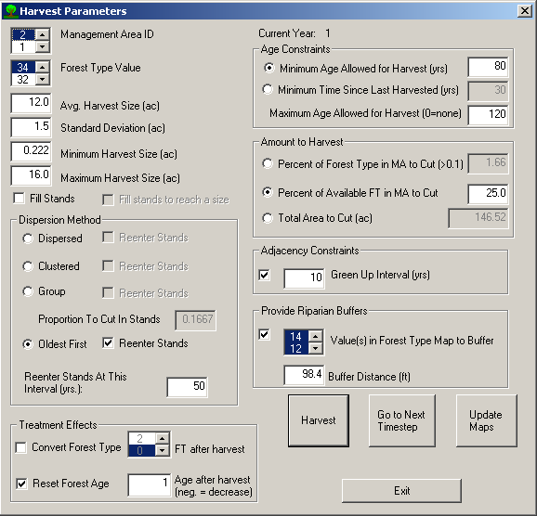

Figure 2. Harvest Parameters Dialog box.

Details of the Harvest Parameters Dialog:

1. Choose the integer value(s) representing the management area(s) and the value(s) representing the forest type(s). Only values actually found in the maps will be offered (except for map values of zero). You may select more than one management area and/or forest type if the harvest parameters are applicable to multiple management area-forest type combinations. To select multiple values, click on the first value, and then select the additional value(s) while simultaneously holding down the Ctrl key on your keyboard. Harvests will be simulated only in stands of the specified forest type(s) located in the specified management area(s).

2. Average harvest size and standard deviation. These values specify a normal (bell-shaped) distribution of harvest opening sizes. HARVEST will randomly select harvest opening sizes from this distribution. You can expect that 95% of the randomly selected sizes will fall within 2 standard deviations of the mean. If you wish to truncate the tails of this size distribution so that sizes are not selected that are less than some minimum or greater than some maximum, enter those limits in the appropriate fields. If you do not wish to impose such limits, simply enter zeros. If you want all harvests to be exactly the same size, enter a standard deviation of 0.0. This will cause the minimum and maximum fields to be disabled, since their values will equal the mean.

If you do not wish to specify the harvest size distribution, but instead require harvest units to follow existing stand boundaries, check the Fill Stands box. This will disable all of the harvest size fields. To specify a harvest size, yet avoid partial cutting of stands, select both the Fill Stands and Fill stands to reach a size check boxes. The average harvest size field (only) will be activated. To approximate this average size, HARVEST will harvest adjacent stands until this size is reached or exceeded.

3. Dispersion method. HARVEST will choose locations for harvests using one of 4 algorithms:
- The dispersed method randomly selects stands (of the designated forest type within the management area) for harvest independently of each other. HARVEST continues to select stands until the target acreage or percentage has been harvested, or until all the stands satisfying the constraints for harvest have been cut.
- The clumped method randomly chooses a focal stand, and then attempts to harvest the stands that are neighbors of its neighbors (potentially creating a ring of harvested stands, one stand removed from the initial stand.) However, these stands may not always be eligible for harvest because they may be a different management area or forest type, or too young. HARVEST attempts to harvest these nearby stands, and then selects a new focal stand and repeats the process until the target acreage has been harvested, or until all the stands satisfying the constraints for harvest have been cut.
- Group selection randomly chooses stands and then harvests small openings (groups or patches) within those stands. When group selection is chosen, you must also specify the proportion of the area of each stand to be removed during each entry into the stand. The default is one-sixth of the stand. This will be used to calculate the total area of the stand that will be turned into harvested openings (i.e., cut) during each entry into the stand. If you imagine a stand as a piece of Swiss cheese, this proportion is analogous to the proportion of the surface of the cheese that is holes. HARVEST continues to select stands until the target acreage has been harvested, or until all the stands satisfying the constraints for harvest have been cut. Note: because group selection places numerous openings within the boundaries of a stand, the Fill Stands option is not available when group selection is specified.
- Oldest first selects from the stands of the designated forest type within the management area in the order of decreasing age. HARVEST continues to select stands until the target acreage or percentage has been harvested, or until all the stands satisfying the constraints for harvest have been cut.
For each of these methods, you may specify a re-entry interval (in years). This allows HARVEST to cut stands on a set rotation. When you press the Harvest button, HARVEST will record for each stand cut the harvest parameters, and the time step when the stand should be cut again. When that time step arrives, HARVEST will automatically cut those stands again, using the same harvest parameters used when the stand was first cut. It will also automatically schedule the next re-entry time step. If you do not select the Re-enter stands check box, harvested stands will again be eligible for selection for harvest when they become old enough. When a re-entry interval is specified, the timing of subsequent harvests in a stand is deterministic; when a re-entry interval is not specified, the random selection process of the dispersion methods described above determines the timing of subsequent harvests. Not checking the re-entry checkbox for group selection may be useful to simulate certain patch-cutting harvest methods. Note: re-entry is not allowed for harvests that convert the forest type to zero, because zero usually represents a generic non-forest type. For harvests that convert forest type to a non-zero value, all re-entries will necessarily be cutting the new forest type.

Under all dispersion methods, stands must always meet minimum age requirements and other specified constraints (e.g., adjacency constraints) before they can be harvested.

4. Treatment Effects. These options specify what changes will be made to a cell when it is ‘harvested.’ Several combinations of effects are possible. Conversion of the forest type without resetting cell age can be used to simulate natural conversions through succession, or removing the dominant species in an even-aged stand. Resetting cell age to an age >1 without converting type could be used to simulate diameter-limit cutting practices, for example. Resetting cells to an age >1 and converting the type could be used to simulate the release of an under-planted species. Decreasing the current age by a specific amount can be used to simulate thinning, where the vertical stand structure is modified so that it now has the structural characteristics of a younger stand. In this case, stand age conceptually acts as a surrogate for stand structural development.

- Convert forest type. Check the checkbox if you wish to change the forest type of the cells that are cut. Select the forest type value that you want the cells converted to. You may not select more than one forest type value. You should not select a forest type that is specified in the Riparian buffers field (see below) because HARVEST produces anomalous patterns when trying to leave buffers around each converted cell. You will receive a warning if you choose to convert to the same forest type that you are harvesting, but HARVEST will not prevent you from doing so. In such a case, no conversion will occur.
- Reset Forest Age. Check the checkbox if you wish to change the age of a cell when it is cut, and enter a value to reflect the new age of the cells. Resetting the cell age to 1 is the default, which duplicates the behavior of all previous versions of HARVEST. Entering a positive value (greater than 0) resets the age of the cells to that value. However, if the new age is greater than the current age of a particular cell, the cell age will not be changed. A negative value (less than 0) decreases the age of the cell by that amount. If such a decrease would reduce the age of a cell to zero or less, an age of 1 is assigned instead. Values for the new age that are less than zero (negative) will decrease the current age of each cut cell by that amount. If such a decrease would reduce the age of a cell to zero or less, an age of 1 is assigned instead. Entering a value of zero precludes cells from being harvested again, and they will no longer increase in age at each time step. HARVEST assumes that all age values of zero are non-forested cells. Setting the age to zero should be done whenever you cause HARVEST to convert the forest type to a non-forest value (e.g., agriculture or permanent openings).

5. Minimum age for harvest. This is comparable to a minimum rotation interval. Forested cells must be at least this old before they can be harvested. To harvest stands on a strict rotation basis, use the re-entry interval described above. An alternative specification for the age constraint is Minimum time since last harvested. This is relevant only for time steps after the first, since HARVEST only uses information found in the Institutional Memory file about previous harvests that may have occurred in a stand. HARVEST will round the number you enter here to the nearest multiple of the time step.

6. Maximum age for harvest. This allows the user to specify the upper age limit for stands and cells to be harvested. A value of zero means that maximum age will not be considered. This feature can be used to simulate the protection of old-growth stands, or to target the treatment effect(s) to a specific range of age classes.

7. Amount to harvest. HARVEST requires an area (which it converts to a number of cells) as a target for cutting. This area can be specified by the user in one of three ways: 1) as a percentage of the area of the forest type in the management area, 2) as a percentage of the area of the forest type in the management area that also satisfies all constraints (amount of available forest type), or 3) as an area entered by the user. If entered as a percentage, HARVEST will quickly scan the age map (by management area and forest type) to determine the area available. If you selected multiple management area-forest type combinations, HARVEST will take their combined area into account. This area will immediately be reported in the ‘Area to be harvested’ field below the ‘Percent’ field whenever you change the percent, the management area or the forest type. HARVEST will attempt to harvest the area specified. It may actually cut more or less, usually within an amount less than half of the mean harvest size specified. HARVEST may not find enough cells to fully allocate your request in every decade. Usually this happens when stands are not completely cut (including riparian buffers). This leaves cells that HARVEST thinks may be available, but the stand history or riparian buffers preclude harvests there. The area actually cut each decade is shown in the text output window and recorded in the log file.

Specifying area for Group selection is not always straightforward. HARVEST expects you to specify the area of the stands to be treated with group selection. However, because only a fraction of the stand area is cut (openings created) in each time step, the area actually cut is always less than the area you specify. To achieve a desired total area cut, adjust the “Total Area Cut” by the “Proportion To Cut in Stands” (e.g. if the proportion is one-sixth, multiply “Total Area Cut” by 6).

8. Adjacency constraints. Check this box if you wish to enforce an adjacency constraint. This constraint prevents HARVEST from cutting a stand that is adjacent to a stand that is younger than the ‘green-up interval’ you specify here. The green-up interval typically is understood to be the length of time it takes for a stand to regenerate sufficiently to no longer be considered a newly harvested opening. Adjacent stands that are in a different management area will not be considered if the Preference setting to Only apply adjacency constraints to same Management Area is checked (see Preferences section above).

9. Provide riparian buffers. Check this box if you wish to prevent cells from being harvested that are within some distance of riparian areas. When this box is checked, you must also select the value(s) found in the forest type map that represents riparian areas (or some other class you wish to buffer, such as roads). To select multiple values, click on the first value, and then select the additional value(s) while simultaneously holding down the Ctrl key on your keyboard. Also specify the minimum distance from these areas where harvests are allowed. HARVEST will round the number you enter here to the nearest multiple of the cell width. HARVEST does not allow you to specify different buffer widths for different classes (e.g., water and roads) in the forest type map. You should not select a forest type that is specified in the Forest Type Conversion field (see above) because HARVEST produces anomalous patterns when trying to leave buffers around each converted cell. You will receive a warning if you select the same forest type, but HARVEST will not prevent you from doing so.

Buttons:

Harvest: Simulates harvesting using the current harvest parameters and returns to this dialog. All harvest openings simulated will be targeted to the specific management area(s) and forest type(s) you selected in the management area and forest type fields of the dialog. When the dialog reappears, you have the option of specifying additional harvests in this, or more likely, other management area/forest type combinations.

Go to Next Time Step: Ends this time step and proceeds to the next time step. Select this button when you have finished simulating harvests in all relevant management area/forest type combinations for the current time step. When HARVEST advances to the next time step, it automatically performs two actions. First HARVEST ages the age map by the length of the time step, and the it re-enters any re-entry stands scheduled for the current time step. HARVEST finds this information in the ‘Institutional memory’ file, and implements re-entries based on the re-entry interval specified when each stand was first cut.

Update maps: Re-draws all open map windows when you wish to see the results of harvests simulated since the last map update. HARVEST maintains the maps in memory, but to save time the maps are only updated on demand, or when Exit is pressed from the Harvest parameters dialog. Also use this button if the map windows become corrupted. Window corruption sometimes occurs if the program is minimized or some other window covers a map window during the map drawing process.

Exit: Ends harvesting and returns to the main HARVEST program. Note: you cannot return to the current time step after exiting. If you resume simulation by choosing Execute and selecting an existing Institutional memory’ file, your simulation will resume at the time step following the one you were in when you pressed Exit.

Program Harvest Script

This option will behave like the ‘Execute’ option, but instead of running simulations, it will save the parameters and rules you specify in a script (text) file, so that you can run the simulation later. This is useful if you want to produce a replicate of a simulation, or wish to modify some parameters for experimental purposes, without having to go through the manual process of inputting all the parameters.

A dialog will ask you to name the script file (which must have an .hsc extension) or, if you wish, select an existing script file. HARVEST can either overwrite the existing script, or append new script to the previous contents. This behavior can be set in the Preferences dialog located under the Edit menu (see the Edit section for more information).

A preliminary dialog box appears with the following check boxes:

- Save age map each time step? If you wish to have a series of age maps automatically saved at the end of each time step, check this box and enter a base filename. The time step number (e.g., 01, 02) will be appended to this name, and saved with a .gis extension. These maps can later be viewed or analyzed for their spatial pattern (load into HARVEST and use Analyze functions, or use other analysis software such as Fragstats (McGarigal and Marks 1993)). NOTE: if a filename already exists at runtime, the file will be overwritten.
- Allow manual harvests after script completes? Check this box if you wish to manually continue the simulation run after the programmed part is finished. The harvest parameters dialog will appear and the time step will not advance from the last time step simulated by the script file.
- Create results table file (spreadsheet format)? Check this box if you want HARVEST to create a comma-delimited file of the input parameters and results, which can later be imported into a spreadsheet program.

The script file can be edited to expedite minor modifications to a simulation. Some users may want to specify all simulations in Program mode, because errors can be edited before executing. HARVEST does not have an Undo option when running in normal Execute mode. It is also possible to copy and paste records in the script file. This can save a tremendous amount of time in specifying multiple time steps – just copy and paste the first time step as many times as needed. Modifications to subsequent time steps may be more easily achieved by editing the script than by specifying them with the Harvest Parameters dialog. Note: Although the records in the script file are numbered, HARVEST does not use the numbers, so they need not be consecutive. You may also append comments on each line, as long as they do not appear where HARVEST expects data. Leaving a couple of blank spaces after the last character on a line is usually sufficient.

Execute Harvest Script

This option will run a previously created script. You will be prompted for the name of the script file, and asked if you would like the harvest parameters written to the log file. An answer of Yes will cause the parameters contained in the script file to be written in the Progress and Results window as the simulation proceeds. The simulations will then proceed without further input from you. If you selected the Allow manual harvests after script completes option, the Harvest parameters dialog box will appear when the script has finished executing. You may simulate additional harvest activity as if you had selected Execute from the Model menu. The time step will not advance from the last time step simulated by the script file. If you wish to begin additional harvesting in the subsequent time step, select the Go to Next Time Step button.

Note: script files prepared with HARVEST 6.0 are not compatible with version 6.1 because each record now has additional lines. It is possible to manually add those lines. Please contact the developer for instructions, or compare v. 6.0 scripts to v. 6.1 scripts to determine the differences in format.

Useful details about how the simulation model works
HARVEST will sequentially harvest stands of the specified forest type(s) in the specified management area(s) until the target harvest amount has been cut. It may actually cut more or less, usually within an amount less than half of the mean harvest size specified. When the Fill Stands option is selected, the target may be exceeded by a considerable amount if stands tend to be large. HARVEST may fall considerably short of the target if all remaining, suitable stands are larger than twice the amount needed to meet the target. HARVEST also may not find enough cells to fully allocate your request in every decade. Usually this happens when stands are not completely cut (including riparian buffers). This leaves cells that the precursory scan by HARVEST shows may be available, but the stand history or riparian buffers preclude harvests there. The area actually cut each decade is shown in the text output window and recorded in the log file.

The ability to specify harvest size allows you to change the scale of patchiness of your landscape. When HARVEST allocates a cut that is smaller than the stand, some cells are left uncut. These cells may be cut at a later time step, especially if the stand is being managed on a rotation. Alternatively, if the size of the harvest is larger than the stand, HARVEST will attempt to achieve the requested size by cutting in an adjacent stand, provided it meets forest type and age requirements, and if cutting the adjacent stand would not otherwise violate adjacency constraints (i.e., ignoring the obvious violation caused by the spillover cutting.) This adjacent stand will also likely be only partially cut.

In some cases the partial cutting of stands creates problems. For example, when converting the forest type of cut cells, HARVEST will assign a new forest type to the stand based on the most abundant forest type within the stand. This may not be the type of the cut cells, and the stand will not be treated as if it were converted in future time steps, even though some cells were converted. To specify a harvest size, yet avoid partial cutting of stands, select both the Fill Stands and Fill stands to reach a size check boxes. If necessary, HARVEST will completely cut suitable adjacent stands (if they are available) to form a cutblock that approximates the desired size. When the Fill stands to reach a size feature is activated, HARVEST does not check against the size parameter until the initial stand has been completely cut, so target sizes smaller than the average size of stands will usually be exceeded.

The ageing of cells is simulated only once per time step, at the very beginning of each time step. Revisit treatments are simulated after the cells are aged, but before any new harvest treatments are allocated, so the age set by the revisit treatment is unchanged until the next time step. The minimum age specified in the Harvest Parameters Dialog is applied to the age of cells at the time of harvest. This has implications for stands that may be treated multiple times through time. For example, given a time step of 10 years, a harvested stand that has its age set to 1 in time step two will have an age of 11 at the beginning of time step three. It will not be eligible for a treatment having a minimum age of 12 until time step four.

The internal (to the model) procedure for simulating harvests can be summarized as follows: 1) build a list of stands that meet the constraints of a) management area, b) forest type, c) age (i.e., greater than or equal to minimum age and less than or equal to maximum age), and d) adjacency (if applicable). 2) Sort the list by age if the Dispersion Method is Oldest first. 3) Select a stand from the list, either by age or randomly. 4) Stochastically generate a target harvest size using the mean and standard deviation specified by the user, except when the Fill Stands option selected. 5) Cut the stand by changing the age and forest type (as specified by user) of cells within the stand. If the Fill Stands option is used, cut every cell in the stand. Otherwise, randomly select a cell, and cut cells in an irregular cutting front away from that cell until the target harvest size is reached. In all cases, do not cut cells that violate riparian buffer or age or forest type constraints. If all eligible cells in the stand are cut and the target harvest size has not been reached (also applies to the Fill Stands to reach a size option), then HARVEST scans a list of neighboring stands (found in the *.mem file) for stands that also meet the constraints, and continues the harvest in the first eligible neighbor stand in the list, beginning with a cell adjacent to the stand just cut. This process continues until the target size has been reached, or until all neighboring stands have been checked. 6) Record information in the *.mem file for the stand(s) cut (e.g., time step when cut, harvest parameters used, revisit interval, etc.) 7) If the target cut area for the management area-forest type combination has not been reached, repeat starting at 3 above. Note: when the Clustered dispersion method is selected, a second list of eligible stands that are near the one selected at step 3 is generated, and when the algorithm returns to step 3, stands are selected from the second list until it is exhausted. 8) When the target area has been reached, the Harvest Parameters Dialog is re-displayed, or the next record from the script file is read.

Notes on selecting harvest parameters.

When simulating thinning or selection cutting, specify a negative age value for Reset cell age. To simulate a thinning regime that increases stand development (more mature within-stand structure) over time, specify a value with an absolute value less than the revisit interval. This results in an average increase in stand age over time. Specifying an absolute value greater than the revisit interval will result in an average decrease in stand age, simulating a regression in stand development over time. Adjacency constraints are rarely applied to thinning or selective cutting activities.

Specify a revisit interval for any management prescription that is static over time, rather than explicitly specifying the activity in each time step in which it should occur. This will save you much time in specifying simulation runs, make script files shorter and reduce run times.

Specify a standard deviation of 0.0 to cause all harvest units to be the same size.

Use the Fill Stands option unless an explicit goal of the management activity is to change the average size of stands (grain size of landscape pattern). The stand-filling option runs much faster, and avoids issues associated with partially cut stands. The Fill Stands to reach a size option provides some control over the size of harvest units, but it is relatively coarse control because HARVEST does not check against the size parameter until after each stand is completely cut.

To simulate a deterministic natural process that always occurs when a forest type reaches a certain age (e.g., succession, dieback), select all the management areas, select the forest type(s) that are affected, set the Minimum Age to the age when the succession begins to occur, Maximum Age to zero, and specify 100% of the Available FT in the MA. The treatment effects should be chosen to reflect the conditions after the successional conversion is complete. For example, aspen stands in Wisconsin die out by age 100, typically leaving stands of northern hardwood species that established some 30 years earlier. This is simulated by specifying a forest type conversion to northern hardwood and resetting age to 30.

Using the analysis features of Harvest 6.1

ANALYZE

This menu item causes HARVEST to conduct an analysis of the patch structure of the current forest age map, or to analyze the amount of interior and edge habitat found in the current forest age map.

Patches

There are two main options for calculating measures of landscape patch (contiguous similar conditions) structure: use the simple calculations provided by HARVEST, or submit the internal maps to APACK (Mladenoff and DeZonia 2004). You may also submit multiple saved maps for patch analysis in batch mode.

HARVEST can calculate the age distribution, the length of linear edge between patches of different ages, the average size of patches of similar age, and the distribution of patch sizes by age class. You have the option of conducting these analyses on the current (internal) age map, or on multiple saved maps in a batch mode. You will be given the option of calculating patches for the entire map, or by specific management area(s). Patches are calculated based on 10-year age classes by default. You may alternatively enter user-defined age classes (two to five classes). To do this, check the ‘Define age classes’ box, select the number of age classes you wish to define, and enter the age ranges for each class. You may modify the labels for each age class that will be printed in the resulting output. The results of these analyses are reported in the Progress and Results window and can be saved as a log file.

If you choose to calculate landscape metrics with APACK, you must choose between the internal stand age map and the forest type map. When analyzing the age map, you may define age classes as described above. You may select among seven Landscape Statistics (APACK term for mean patch characteristics), calculated by class (either age class or forest type class), and three Class statistics (total area of each class, proportion of the total area in each class and a connectivity index). Specific APACK switches used are: aa, ap, cor, ed, fd2, swd, ai, ar, ra and cce. Consult the APACK user’s guide for details about how the indices are calculated and what they mean. The indices offered by HARVEST are a subset of those calculated by APACK. If you require other APACK indices, contact the developer. The results of APACK analyses are saved in files whose names are written to the log file.

NOTE: if you wish to use the APACK option, you must first download APACK (http://landscape.forest.wisc.edu/projects/apack/) and install it in the directory from which you run HARVEST, or be sure its directory is on the DOS PATH of your machine. Also note that APACK does not support directory names containing spaces.

Interior

This option will calculate several indices based on the distance of cells from harvested and non-forest openings. Calculated are the amount of interior and edge habitat, and the GISfrag index (Ripple et al. 1991). GISfrag is the average distance of a forested cell from the nearest opening or edge, and it is a good index of fragmentation because it is not susceptible to patch truncation effects. Each of these indices considers both harvested cells and the non-forest types in the forest type map to be forest openings. There are two ways that you can perform interior analysis: either for the Current Map or for Multiple Maps. For all analyses conducted, information from both the stand age and forest type maps is used.

You will be prompted to enter an Interior buffer distance. This is the distance that edge effects extend into the forest, and should be selected based on the ecological process(es) that are of interest. (You may wish to conduct several analyses at various buffer distances.) HARVEST will convert the distance you enter to the nearest number of pixels, so the actual value used will be a multiple of the pixel width. This information is recorded in the running log.

You will also be asked to enter the number of decades that harvested openings persist. When analyzing forest interior and edge, any stand less than or equal to this age will be considered a forest opening. Stands older than this age are assumed to have returned to a closed canopy condition. This value must be a multiple of the length of the time step, and should be selected with knowledge of the local forest regeneration rates and the ecological process(es) of interest.

You will also be prompted for the value(s) representing non-forest in the forest type map. Cells having this value will also be considered openings when calculating forest interior. All other values will be considered forest. To select multiple values, click on the first value, and then select the additional value(s) while simultaneously holding down the Ctrl key on your keyboard.

The results of this analysis are reported in the Progress and Results window and can be saved as a log file. The interior map may also be saved as a .gis file. The results of Multiple Map analysis can be saved in a comma-delimited file that can later be imported into a spreadsheet program.

Complete

If you choose to perform either patch or interior analysis for multiple age maps, you will be given a Windows dialog to select the first file in the map series, followed by a dialog to select the last map in the series. All of the maps in the series must have the same base name, and must be sequentially numbered from the first map to the last map selected (i.e. Map01.gis, Map02.gis…Map15.gis). You will also be asked to enter a filename where the tabular output will be stored in a comma-delimited format. The parameters dialog will be displayed just as it is for single-map analysis, and the parameters will be applied to each map in the series. Results for each map analysis will be displayed in the log window. Interior maps will be saved using the base names of the input maps with ‘_int’ appended to each name. Note: Existing files will be overwritten.

HARVEST will also submit multiple maps to APACK. The procedure is similar to that for requesting multiple patch analyses. HARVEST execution will pause until all the APACK analyses are completed.

Query Stand

Select this option to interactively investigate the characteristics of specific stands in the stand age map. Using the left-click button on the mouse, select a cell within a stand. A dialog box will appear showing the following information about the cell and the stand it is in: Stand ID number, stand size, average age of the cells in the stand, the management area the stand is in, the forest type of the stand, year last treated, treatment code, and revisit interval. The treatment code reflects the Dispersion Method used when the stand was last cut (1 = Dispersed, 2 = Clustered, 3 = Group Selection, 4 = Oldest First). Stands that were cut using a negative Reset cell age value will have a 4 added to the treatment code value (e.g., Dispersed = 5, Oldest First = 8). Negative Reset cell age values typically represent an uneven-aged treatment, and this feature will allow the user to distinguish them from even-aged treatments. In some cases the actual stand boundaries will not be evident from the ages of the cells, because the stand ID map is not shown. When you are finished, press the Close button. Although many HARVEST functions can be used with the Query Stand dialog open, some will not respond until the dialog is closed.

WINDOW

This menu allows the user to bring windows to the front for viewing. Selecting the Forest Type or Management Area items will cause a new window to be generated to display the selected map if it has not yet been opened, or it will bring the window to the front if it already has been opened.

HELP

The help menu provides access to an electronic version of the document you are now reading. You may also determine the version of HARVEST you are using by selecting About.

MAP FILES

The output maps produced by HARVEST are saved in an ERDAS 7.5 file format. To import these files into Arc GRID format, use the IMAGEGRID command at the arc: prompt (not the grid: prompt). They can be directly read by ArcGIS, ArcView and ERDAS Imagine.

COMMA-DELIMITED FILES

If you choose to create a list of all log output for export to a spreadsheet, HARVEST saves the data as a comma-delimited file. Most spreadsheet programs provide capabilities to import such data. You may have to specify the delimiter (in this case a comma “,”), and the spreadsheet program should automatically import the data, including the column headings.

Script file format

The script file is a flat text file that can be edited to specify lengthy and complex simulation runs. Because the file is read by HARVEST as a formatted file, it is critical that information appear on the correct line and in the correct column. The recommended way to produce a script file is to use the Program harvest script under the Model menu in HARVEST to produce at least the first several harvest actions (script records). The script can then be expanded by copying and pasting records and editing the details in the records.

A sample script file is given here. Data type of the fields appear in the column where HARVEST begins reading data, and are indicated by Fortran format statements: A represents characters, I represents integers, F real numbers; the number following the letter indicates the number of columns read. F formats also indicate the number of columns after the decimal point, but the number to the left of the decimal is the total columns read. Note that a leading space occurs in every line. Text after the pound sign (#) is a comment. HARVEST ignores all text after the last column read (as indicated by the format statements).

[GLOBALS-Harvest6.1] # Header text must appear exactly as shown here

Inst Mem File Name : A100

Random Number Seed : I10

Save Age Maps? : A1 # Any character except (capital) Y will be interpreted as No

Save For. Type Maps?: A1 # Any character except Y will be interpreted as No

Map Base Name : A100

Manual Harvests? : A1 # Any character except Y will be interpreted as No

Create Log List? : A1 # Any character except Y will be interpreted as No

Log List File Name : A100

Time Step Length : I3

[RECORD NUMBER 1] #Value of record number is ignored by HARVEST

Mng Area ( 1) : I3 #Value in parentheses will be ignored

Mng Area ( n) : I3 #Multiple MAs (2-n) will appear only if selected

Forest Type ( 1) : I3 #Value in parentheses will be ignored

Forest Type ( n) : I3 #Multiple FTs (2-n) will appear only if selected

Mean Harv Size : F8.2

Standard Deviation : F8.2

Min Harvest Size : F8.2

Max Harvest Size : F8.2

Stand Filling? : A1 # Any character except Y will be interpreted as No

Fill stand to size? : A1 # Any character except Y will be interpreted as No

Dispersion Type : A9 # Must be one of: Dispersed, Clustered, Oldest, Group

Group Proportion : F7.4

Revisit Interval : I3

Minimum Age/Time : A4 # Must be one of Age, Time

Minimum Age : I3

Maximum Age : I3

Harv Calculated By : A8 # Must be one of Area, Pct, PctAvail

Amount to Harvest : F8.2

Adjacency Constr? : A1 # Any character except Y will be interpreted as No

Green-Up Interval : I3

Riparian Buffers? : A1 # Any character except Y will be interpreted as No

Val to Buff ( 1) : I3 #Value in parentheses will be ignored

Val to Buff ( n) : I3 #Multiple FTs (2-n) will appear only if selected

Buffer Width : F5.1

Treatment Code : I3 See footnote *

Convert Forest Type?: A1 # Any character except Y will be interpreted as No

Convert FT To : I3

Reset cell age? : A1 # Any character except Y will be interpreted as No

Reset cell age to : I4

Last Harv In TS? : A1 # Any character except Y will be interpreted as No

[END OF RECORD] # Text must appear exactly as shown here

[RECORD NUMBER n] #Subsequent records may follow

* Treatment codes are: 1=Dispersed, 2=Clustered, 3=Group, 4=Oldest First; when a negative age is specified for Reset Forest Age, a 4 is added to these values to indicate uneven-aged treatment.

Common problems and how to fix them

Problem: HARVEST warns me that there are not enough colors available.

Fix: Go to the Windows Control Panel and select 'Display'. Set colors to 'High color (16-bit)'. You may need to re-start your computer for this change to take effect.

Problem: When selecting maps, I always receive this message: "The selected maps have different properties, use anyway?" The maps have the same properties. It even happens after selecting the "fix header of this map" option.

Fix: Select Edit - Preferences. You may have selected either metric or English units to be the default. Whatever it is set to, change it and see if the problem goes away.

Problem: When pressing the harvest button after entering the harvest parameters, the following error message appears: 'Please select a different land use or management area.’'

Fix: This message appears because the parameters selected resulted in a total amount to cut of 0 acres/ha. You must change the parameters to produce a non-zero cut amount (the amount that will be harvested is in ‘Total area to cut’ box of the HARVEST parameters dialog). This is typically done by selecting other management area(s) or forest type(s), or lowering the minimum age for harvest.

Problem: When refreshing a map window, it changes shape and is left blank.

Fix: Close the window and open it again using the Window menu.

Using HARVEST for research or strategic planning
REPLICATES

Because HARVEST is a stochastic simulation model, you will get a somewhat different result each time you run a given set of parameters on the same set of maps (if you use a different random number seed). However, this is also true in real life, where you will get different management plan implementations if you give different project-level planners the same task. Remember that the purpose of HARVEST is to simulate the project-level (stand-level) implementation of a strategic-level plan. This will provide an expected landscape spatial pattern given the management strategy simulated.

To understand an expected outcome requires statistical methods and replicated observations. It is recommended that simulation replicates be generated whenever data are produced to support a decision or a research finding. A simulation replicate is a repeated simulation run where only the random number seed is changed. The question of how many replicates are required depends on how much variation exists among replicates. A minimum of 3 replicates should be produced to assess the between-replicate variation in measures of spatial pattern (e.g., amount of interior, mean patch size.) Consult with a statistician to determine the number of replicates required.

Using script files is the recommended way to manage replicate simulations. Make a copy of the script file for each replicate and change only the random number seed in each. You can manage the output files by using either a base filename that identifies the replicate, or specifying a separate directory (as part of the base filename) for each replicate. The base filename can include the file system path, and is specified in the header of the script file. It is possible to simultaneously run several instances of HARVEST, but they must be invoked from separate directories to keep the temporary log file ($temp.txt) from being corrupted. The simplest way to do this is to copy the executable (and rgb.dat and defaults.sys) into the several directories.

ALTERNATIVE SCENARIOS

HARVEST is a powerful tool to compare the spatial pattern expected under alternative management scenarios. These alternatives may differ in the boundaries and objectives of management areas, the intensity of harvest (area cut), the size of harvest units, the dispersion of openings, or some combination. Furthermore, the strategies may change over time in various ways. To see some examples of such comparisons, see Gustafson and Crow (1996), Gustafson (1996), Gustafson and Crow (1998), Gustafson (1998), and Gustafson et al. (in press).

HARVEST is not a tactical planning tool

HARVEST is a strategic-level planning and research tool. It should not be used to support project-level planning except as a heuristic (what-if?) device. To make HARVEST easy to use for strategic, coarse-filter evaluation of management alternatives, many simplifying assumptions were made to reduce data requirements and processing time. Because HARVEST ignores many forest conditions and constraints that are critical in tactical planning, it cannot be expected to provide guidance on the specific location of individual timber sales.

ASSUMPTIONS

A number of key assumptions were made in the development of HARVEST to maintain its ease of use as a strategic planning and research tool. Users of HARVEST should keep these in mind as they interpret and apply the results from simulations.

- Forest age is used as a surrogate for merchantability. It is assumed that the likelihood of harvest of a stand of a given forest type within a management area is related solely to the age of the stand. However, we know that stocking density, size class, site conditions, accessibility and operability are all factors that influence stand growth and harvest decisions in reality.
- HARVEST randomly selects suitable stands. When HARVEST does not select stands using the Oldest First method, stands are selected at random from those stands that satisfy age and adjacency constraints. Over a time period of a decade or more, this mimics the pattern found on real managed forests (Gustafson and Crow 1999). For shorter time periods this may not be the case. When multiple forest types and/or multiple management areas are selected, harvests are distributed among the combined area of the forest type(s) and management area(s).
- Forest type of a stand is assigned based on the type that is most abundant within the stand. When forest type conversion is active, forest type of a stand is re-computed immediately after it is cut, based on the type that is most common within the stand boundaries.
- Forest succession processes are not simulated. This lack of succession may be unrealistic for certain forest types under uneven-aged management. However, if the treatments targeted to forest types are designed to maintain those types, then this will not be a problem. Some succession may be simulated by converting the forest type of stands when they reach a certain age. This should be attempted only when the succession process for that forest type is fairly deterministic. If the user is interested in how forest composition might change by succession under alternative management strategies, then HARVEST is not the tool to use. The LANDIS model is one option to consider for such questions, since it is a process-based model that includes succession processes (http://landscape.forest.wisc.edu/projects/landis.htm).
- Stand boundaries do not change, even when the harvest boundaries are significantly different than the original stand boundaries. The original stand boundaries are maintained solely for bookkeeping purposes. This normally does not create problems, but has the potential to create a logistical limit to harvest activity if simulated harvests are generally much smaller (or somewhat larger) than the original stands.

INTERIOR

Analysis of forest interior and edge habitat requires the user to provide information to define what is to be considered forest interior. Interior conditions are generally not so much a physical phenomenon as an ecological phenomenon that arises from the perception of habitat quality by organisms. Microclimate edge effects usually extend into the forest only a few tens of meters. However, some bird species avoid habitat within several hundred meters of a forest edge. The user must have a specific ecological question in mind when requesting an interior analysis, and define interior conditions accordingly. In some cases, several analyses using different definitions of interior may be conducted to provide estimates of interior conditions relevant to different species or ecological communities.

PATCHES

Patches are defined as a collection of contiguous cells, connected edge-to-edge or diagonally, whose ages are all in the same age class (e.g., 1-10, 30-60). HARVEST allows the user to define the age classes. HARVEST always assumes cells are part of a patch if they are connected diagonally; APACK allows the user to choose the connection rule. Forest type is not considered in the patch delineation process, except by APACK.

LINK TO SPECTRUM

A utility program was developed to convert output from the harvest-scheduling program Spectrum into a script file that can be used as input to HARVEST. This allows Spectrum schedules to be simulated in a spatial context (e.g., Gustafson et al. in press, Leefers et al. in press). For more information on this utility program and its use, contact Eric Gustafson, or visit the HARVEST Web site (http://www.ncrs.fs.fed.us/4153/Harvest/v61/v6_1.htm).

References
Gustafson, E.J. 1996. Expanding the scale of forest management: allocating timber harvests in time and space. Forest Ecology and Management 87:27-39.

Gustafson, E.J. and T.R. Crow. 1996. Simulating the effects of alternative forest management strategies on landscape structure. Journal of Environmental Management 46:77-94.

Gustafson, E.J. 1998. Clustering timber harvests and the effect of dynamic forest management policy on forest fragmentation. Ecosystems 1:484-492.

Gustafson, E.J. and T.R. Crow. 1998. Simulating spatial and temporal context of forest management using hypothetical landscapes. Environmental Management 22:777-787.

Gustafson, E.J. and T.R. Crow. 1999. HARVEST: linking timber harvesting strategies to landscape patterns. In Spatial modeling of forest landscapes: approaches and applications, Mladenoff, D.J. and W.L. Baker (eds). Cambridge University Press, Cambridge, England.

Gustafson, E.J. 1999. HARVEST: a timber harvest allocation model for simulating management alternatives. In Landscape ecological analysis: issues and applications, Klopatek, J.M. and R.H. Gardner (eds). Springer, New York.

Gustafson, E.J., L.J. Roberts, and L.A. Leefers. In press. Linking linear programming and spatial simulation models to predict landscape effects of forest management alternatives. Journal of Environmental Management.

Leefers, L.A., L J. Roberts and E.J. Gustafson. In press. Spatial sensitivity analysis: an application of HARVEST to a Spectrum alternative. In: Bevers, Michael; Barrett, Tara M., comps. Systems Analysis in Forest Resources: Proceedings of the 2003 Symposium; October 7-9, Stevenson, WA. Gen. Tech. Rep. PNW-GTR-000. Portland, OR: U.S. Department of Agriculture Forest Service, Pacific Northwest Research Station.

McGarigal, K., and B. J. Marks. 1995. FRAGSTATS: spatial pattern analysis program for quantifying landscape structure. Gen. Tech. Rep. PNW-GTR-351. USDA Forest Service, Pacific Northwest Research Station, Portland, Oregon, USA.

Mladenoff, D.J. and B. DeZonia. 2004. APACK 2.23 analysis software: User’s guide. Published on Internet server http://landscape.forest.wisc.edu/projects/apack/

Ripple, W.J., G.A. Bradshaw, and T.A. Spies. 1991. Measuring landscape pattern in the Cascade Range of Oregon, USA. Biological Conservation 57:73-88.

Citation information
This User’s Guide should be cited as:

Gustafson, Eric J. and Luke V. Rasmussen. 2005. HARVEST for Windows v6.1: User’s guide. Published on the Internet by the USDA Forest Service, North Central Research Station, St. Paul, MN. URL: http://www.ncrs.fs.fed.us/4153/harvest/v61/documentation/default.asp.

